LAST WILL AND TESTAMENT
I, ……………………………………………………………………………………………….………..
Father's name: …………………………………………………………………………………………
henceforth referred to in this document as (legal name):……………….…………………………
…………………………………………… - of the address of:……………………………………….
………………………………………………………………………………….………………………..
being of sound mind and memory, do hereby revoke all previous Wills and Codicils by me made, and do make, ordain, publish and declare this to be my Last Will and Testament.
Article 1: Preamble
I bear witness that there is no Deity but Allah, the Merciful, Almighty God - Creator of the Heavens and the Earth and all therein - God of Ibrahim, Moussa, 'Issa, Muhammad and all the Prophets, Mercy and Peace be upon them all. I bear witness that HE is the ONE God and that HE has no partner and that Muhammad is HIS Messenger and the last of the Prophets, Mercy and Peace be upon them all. I bear witness that Allah is the Truth, that HIS Promise is the Truth and that the Meeting with HIM is the Truth. I believe in the Day of Judgment, and that there is no doubt about it, that Allah, Who is Exalted above all deficiency and imperfection, will surely resurrect the Dead of all generations of Mankind, first and last, and all those in between.
My council to my relatives, friends, my Muslim Brothers and Sisters and all who remain after me is the following: Strive to be true Muslims, submit to the will of your Creator -may HE be exalted - worship HIM as HE alone is to be worshipped, fear HIM as HE alone is to be feared and love HIM and HIS Prophet with a complete love that is rivalled by nothing. Obey HIM and hold fast to HIS Shari'ah, Spread and firmly establish HIS Religion of Islam and die only in a state of complete submission to HIS will.
I furthermore wish to remind them that no man and no woman dies before his/her time, and that the precise duration of each life-span is determined by the All-Powerful Creator - may HE be exalted - before his/her birth. Being Muslims they should keep in mind that death is tragic only for those who have lived out their lives in self-deception, without having submitted to the Will of their Creator and without being prepared for the final return to HIM. I therefore ask them not to be preoccupied because of my death but instead make proper preparations for their own.
Maintain patience and self-composure, as the religion of Islam requires. Islam permits relatives to mourn for no more than three days, although a widow is allowed to mourn for four lunar months and ten days, until her iddah (period of waiting) is completed.
Testator………………….. 1. Witness………….…….……… 2. Witness …………….………….
1st page of my Last Will and Testament Date; ……………………….
The Creator forbids wailing and excessive lamentation, and it reflects only a lack of understanding and dissatisfaction with the Will of the Creator, may He be exalted.
Finally, I request my relatives and friends and all other persons who may have to deal with this document - whether they believe as I believed or not - to grant me the Constitutional Right to these beliefs. I ask them to honour this document and neither obstruct its execution nor change it in any way. Rather, I expect them to make every effort to divide my property as expressed in it and to bury me the way I choose to be buried.
Article II - Funeral and Burial Rites
a) I ordain that no autopsy or embalming be done on my body unless required by law. I furthermore wish that my body - without justified delay - be washed, wrapped in cloth, without any ornaments, be prayed for and then be buried. All this must be done by Muslims and in complete accordance with the Religion of Islam.
b) I therefore nominate and appoint …………………………………………………………………
of the following address ………………………………………………………………………………
City of …………………………………………………………………………………………………...
to execute these orders for my proper Islamic funeral and burial. In the event that he/she be unwilling or unable to execute them, I nominate and appoint the Muslim Community of the area where I died to make these necessary provisions.
c) In the event of legal difficulties in the execution of this Article, I direct the above named person to seek counsel from the Islamic Information Service, PO Box 62125, Mt Wellington, Auckland 1130, NZ. Phone/Fax: 09-5794611
d) I ordain that absolutely no non-Islamic religious service or observance shall be conducted upon my death or on my body.
e) I ordain that no pictures, crescents or stars, decorations, crosses, flags, any symbols - Islamic or otherwise - or music shall be involved at any stage of the process of conducting my burial or ever be placed at the site of my grave.
f) I ordain that my body shall not be transported over any unreasonable distance from the locality of my death, particularly when such transportation would necessitate embalming, unless when long distance transportation is required to reach the nearest Muslim cemetery or any other cemetery selected by my Muslim family.
g) I ordain that my grave shall be dug deep into the ground in complete accordance with the specifications of Islamic practice and that it face the direction of Qiblah (the direction of the city of Mecca in the Arabian Peninsula, towards which Muslims face for prayer).
Testator………………….. 1. Witness………….…….……… 2. Witness …………….………….
2nd page of my Last Will and Testament Date; ……………………….
h) I ordain that my body shall be buried without a casket or any encasement that separates the wrapped body from the surrounding soil. In the event that local laws require casket encasement, I ordain that such encasement be of the simplest, most modest, and least expensive type possible. I further ordain that the encasement be left open during burial and filled with dirt, unless prohibited by law.
i) I ordain that my grave shall be level with the ground or slightly mounded, with no construction or permanent structure of any kind over it. The marking-if necessary-should be a simple rock or marker, merely to indicate the presence of the grave. There should be no inscriptions or symbols on the said marking.
Article III - Debts and Expenses
a) I direct that all trust properties shall be returned to the rightful owners. I further direct that my executor, hereinafter named, apply first the assets of my estate to the payment -of all my legal debts including such expenses incurred by my last illness and burial, as well as the expenses for the administration of my estate.
b) I direct that the amount of NZ$…………………………. (in words…………………………….
…………………………………………………………………………………) be paid to my wife
representing the portion of her dowry payment which had been delayed.
c) I direct that any outstanding 'obligations to Allah' (Huquq-Allah) which are binding on me, be paid. These may include the following:
1. Unpaid Zakat for the years 19….... to ……………. This amount should be calculated
from my total estate according to the Shari'ah or I estimate it as NZ$……………………
2. Kaffarat (atonements) for unperformed prayers, neglected fasting, alms giving etc. which I estimate to amount to NZ$……………….. and which I direct to be paid to 'Islamic Information Service' or to ……………………………………………………………
3. Unperformed Hajj (Pilgrimage) I direct that a Muslim be sent to perform Hajj on my behalf. Only a brother/sister who has already performed his/her own Hajj is entitled to carry out this task. The expenses for the entire journey must be paid from my estate.
.d) I further direct that all inheritance, estate and succession taxes payable by reason of my death, be paid out of and charged to my residuary estate.
Testator………………….. 1. Witness………….…….……… 2. Witness …………….………….
3rd page of my Last Will and Testament Date; ……………………….
Article IV - Charitable Contributions and Testamentary Transfer
a) I direct that my executor pay the following contribution to the below named organizations and persons:
Islamic Information Service Percent of remainder
PO Box 62125 of my estate after
Mt Wellington the execution Of Article III
Auckland 1130, NZ
1. General activities …………%
2. Burial of poor Muslims of New Zealand …………%
3. Establishment of orphanages and nursing homes for the aged …………%
4. Acquisition and maintenance of Mosques and Islamic Centres …………%
5. Sponsorship for Muslim students …………%
6. Funding Islamic Conferences, Research Work and Islamic Publications …………%
7. Establishment of Islamic Schools and libraries …………%
8. Charity Fund & Social work …………%
9. Other Organizations …………%
………………………………………………………………………………. …………%
………………………………………………………………………………. …………%
………………………………………………………………………………. …………%
………………………………………………………………………………. …………%
………………………………………………………………………………. …………%
………………………………………………………………………………. …………%
………………………………………………………………………………. …………%
………………………………………………………………………………. …………%
………………………………………………………………………………. …………%
Subtotal …………… …………%

Carrying over
Other organisations: ……………………………………………………. …………%
………………………………………………………………………………. …………%
………………………………………………………………………………. …………%
………………………………………………………………………………. …………%

Persons:.……………………………………………………………………. …………%
………………………………………………………………………………. …………%
………………………………………………………………………………. …………%
………………………………………………………………………………. …………%
Testator………………….. 1. Witness………….…….……… 2. Witness …………….………….
4th page of my Last Will and Testament Date; ……………………….
b) I further direct that my executor transfer the following in kind (real estate, car, books, tapes, records etc.) to the organizations and persons named below:
'Islamic Information Service' PO Box 62125, Mt Wellington, Auckland 1130, NZ
………………………………………………………………………………. …………%
………………………………………………………………………………. …………%
………………………………………………………………………………. …………%
Other Organisations:. ………………….…………………………………. …………%
………………………………………………………………………………. …………%
………………………………………………………………………………. …………%
Persons:……………………………………………………………………. …………%
………………………………………………………………………………. …………%
………………………………………………………………………………. …………%
Total (not more than 33.33%) …………%
Article V - Distribution of Remainder
a) I direct, device and bequeath all residue and remainder of my estate, after the execution of Articles III and IV, to my Muslim heirs only, whose relationship to me, whether ascending or descending, has occurred through Islamic marriage at each and every point. This distribution must be carried out strictly in accordance with the schedule attached herewith (pages 15 to 24).
b) Should I die of murder, I direct that the adjudged murderer and his principle accomplice be excluded from all inheritance of my estate.
c) I further direct that no part of my estate be given to relatives whose relationship to me, whether ascending or descending, has occurred through non-Islamic or unlawful marriage, except the following:
1. Legatees specifically named in Article IV.
2. A person who is related to me through his or her biological mother.
d) I direct and device that any foetus conceived before my death, whose relationship to me would qualify it to be an heir of mine according to this article be considered as such if the child is born alive within a maximum of 354 days after my death. In such a case I direct and device that the procedure of distribution, after the execution of Articles III and IV, be delayed until the birth of the child.
Testator………………….. 1. Witness………….…….……… 2. Witness …………….………….
5th page of my Last Will and Testament Date; ……………………….
e) I further, bequeath the remainder of my estate, after the execution of Articles Hi and IV and sections a. through e. of Article V, to the 'Islamic Information Service'. I further direct that any portion of my estate disclaimed or refused by any legatee named or referred to in this Last Will and Testament be also given to the 'Islamic Information Service'.
List of Heirs according to the Shari'ah

Male Heirs
1. Husband
2. Father
3. Son (s)
4. Grandfather (s)
5. Grandson (s) (son of a son)
6. Brother (s) from the same parents
7. Brother (s) from father's side only
8. Brother (s) from mother's side only
9. Father's brother (s) from the same grandparents
10. Father's brother(s) from father's side only
11. Son (s) of brother (s) from the same parents
12. Son (s) of brother (s) from father's side only
13. Son (s) of brother (s) of father from the same grandparents
14. Son (s) of brother (s) from mother's side only
Female heirs
15. Wife (ves)
16. Daughter (s)
17. Mother
18. Daughter (s) of son (s)
19. Mother of mother
20. Mother of father
21. Sister (s) from the same parents
22. Sister (s) from father only
23. Sister (s) from mother only
Testator………………….. 1. Witness………….…….……… 2. Witness …………….………….
6th page of my Last Will and Testament Date; ……………………….
List of Living Heirs

Degree of Relationship | Name | Address

Testator………………….. 1. Witness………….…….……… 2. Witness …………….………….
7th page of my Last Will and Testament Date; ……………………….
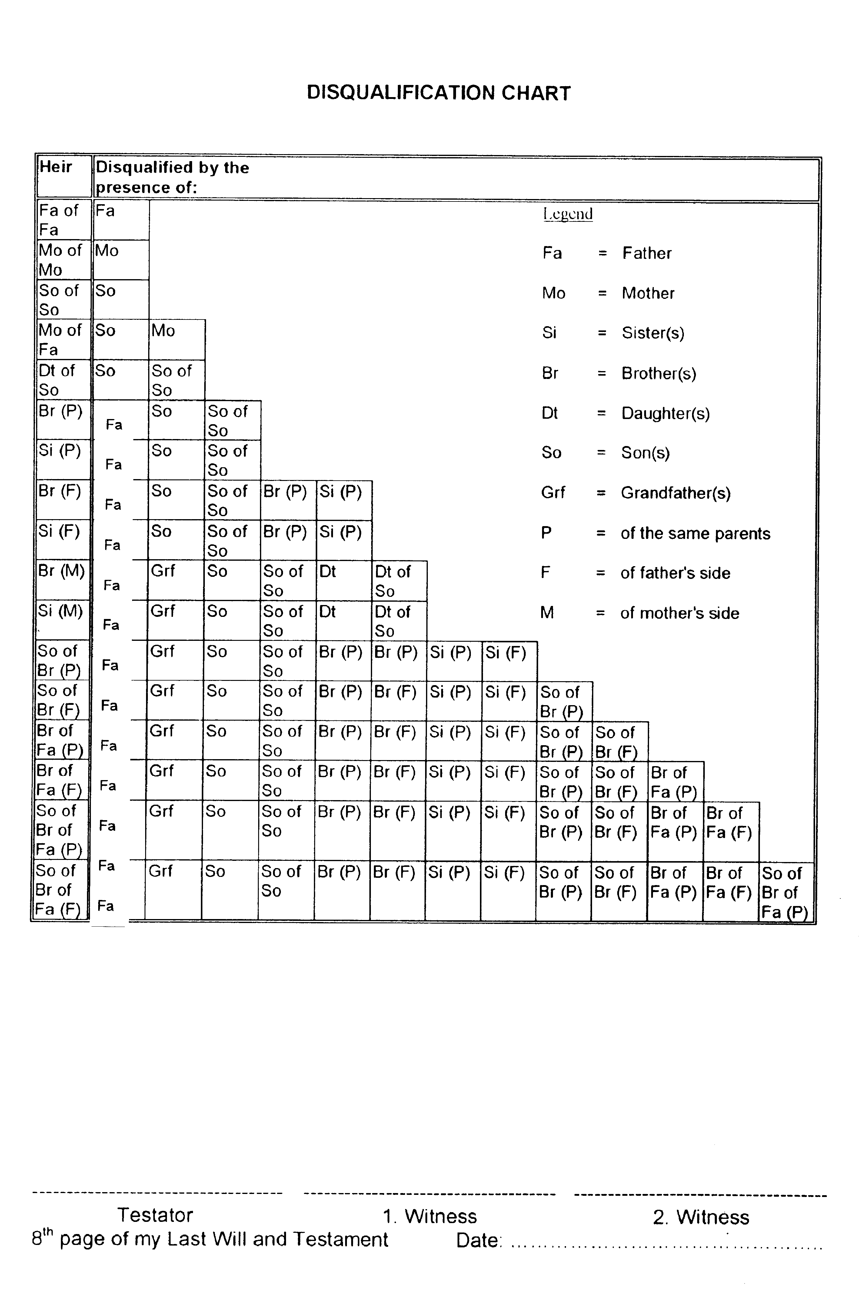
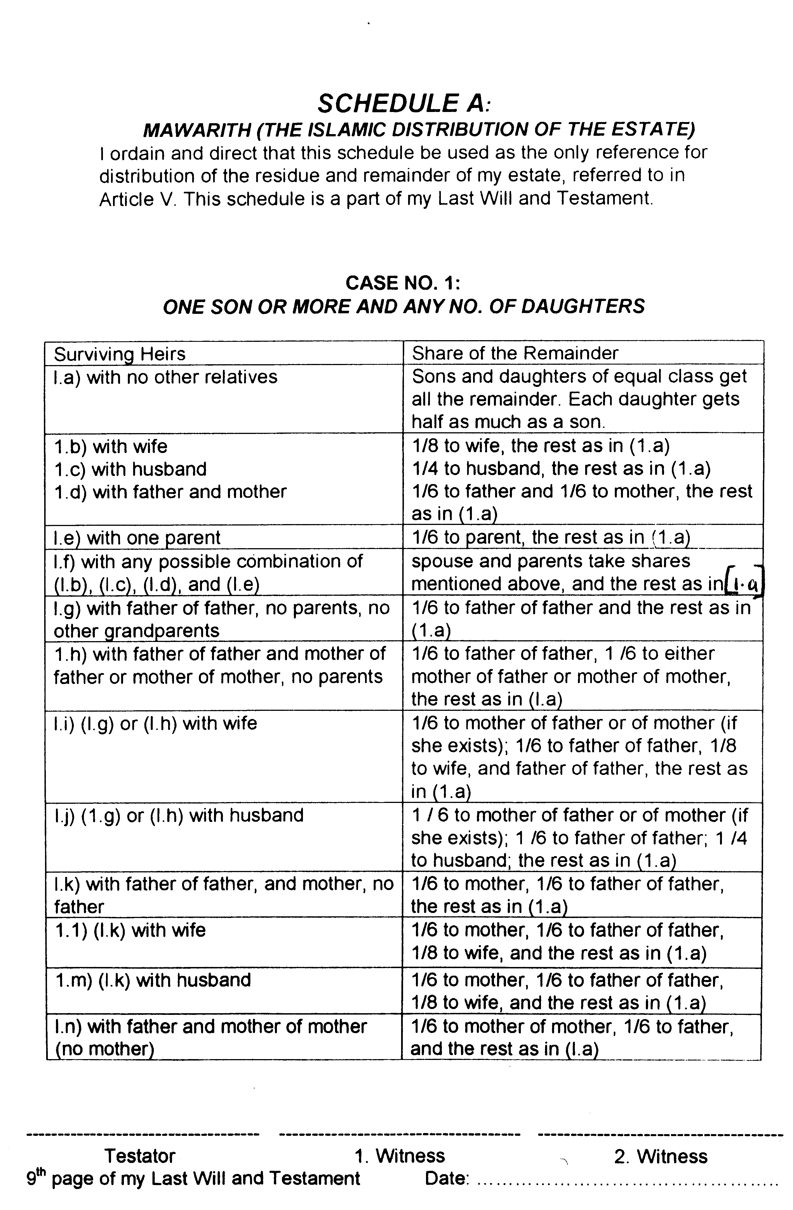
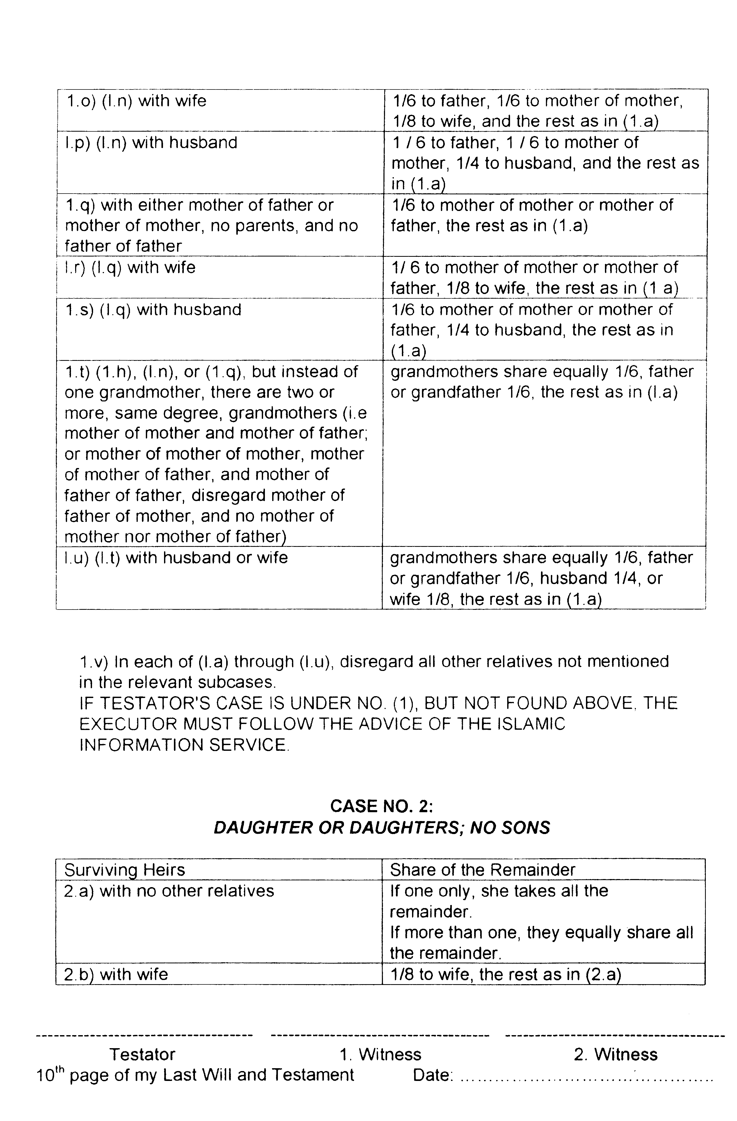
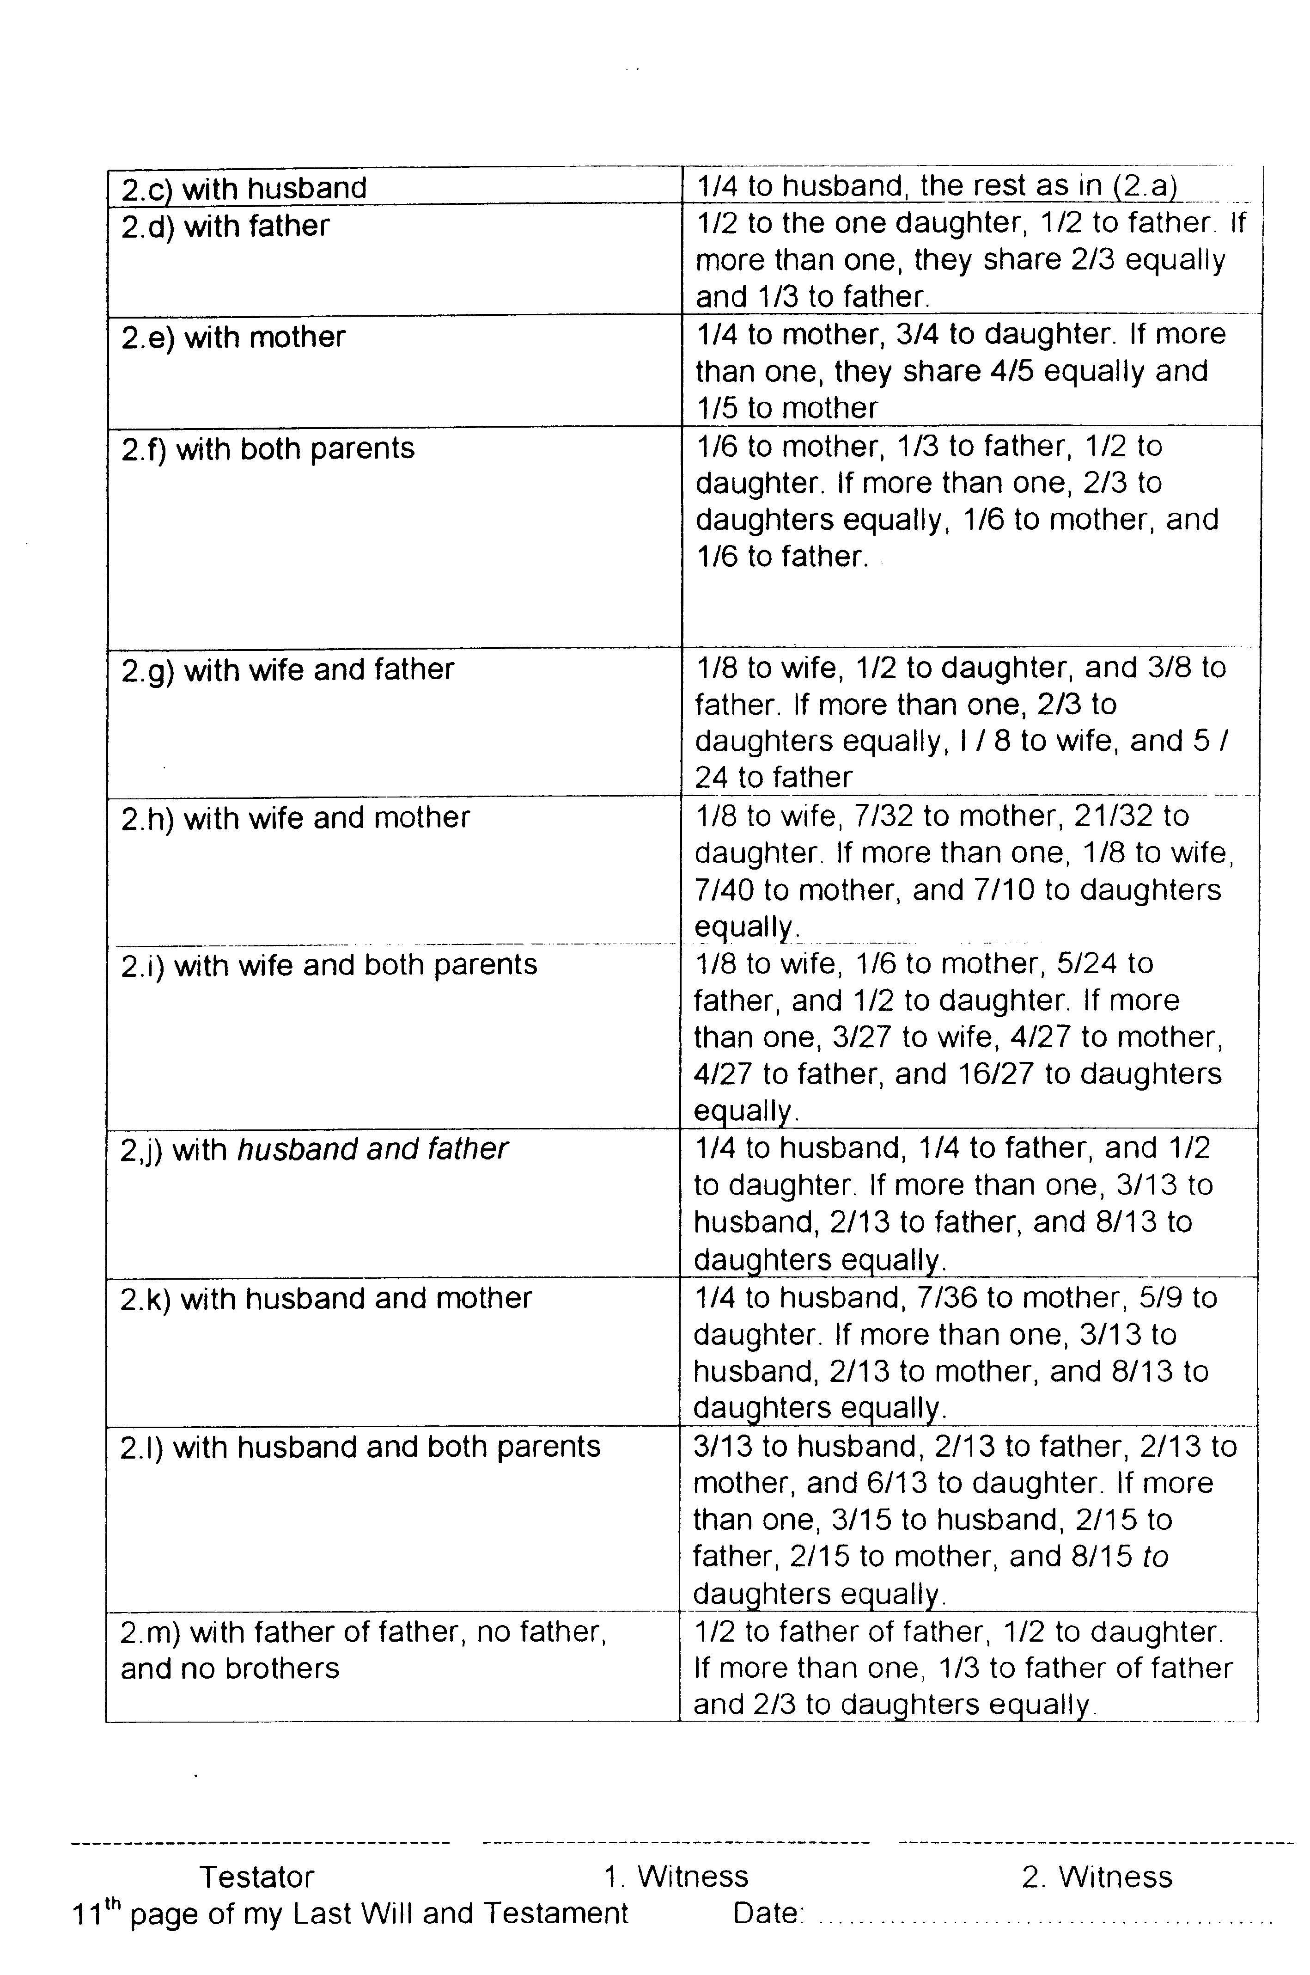
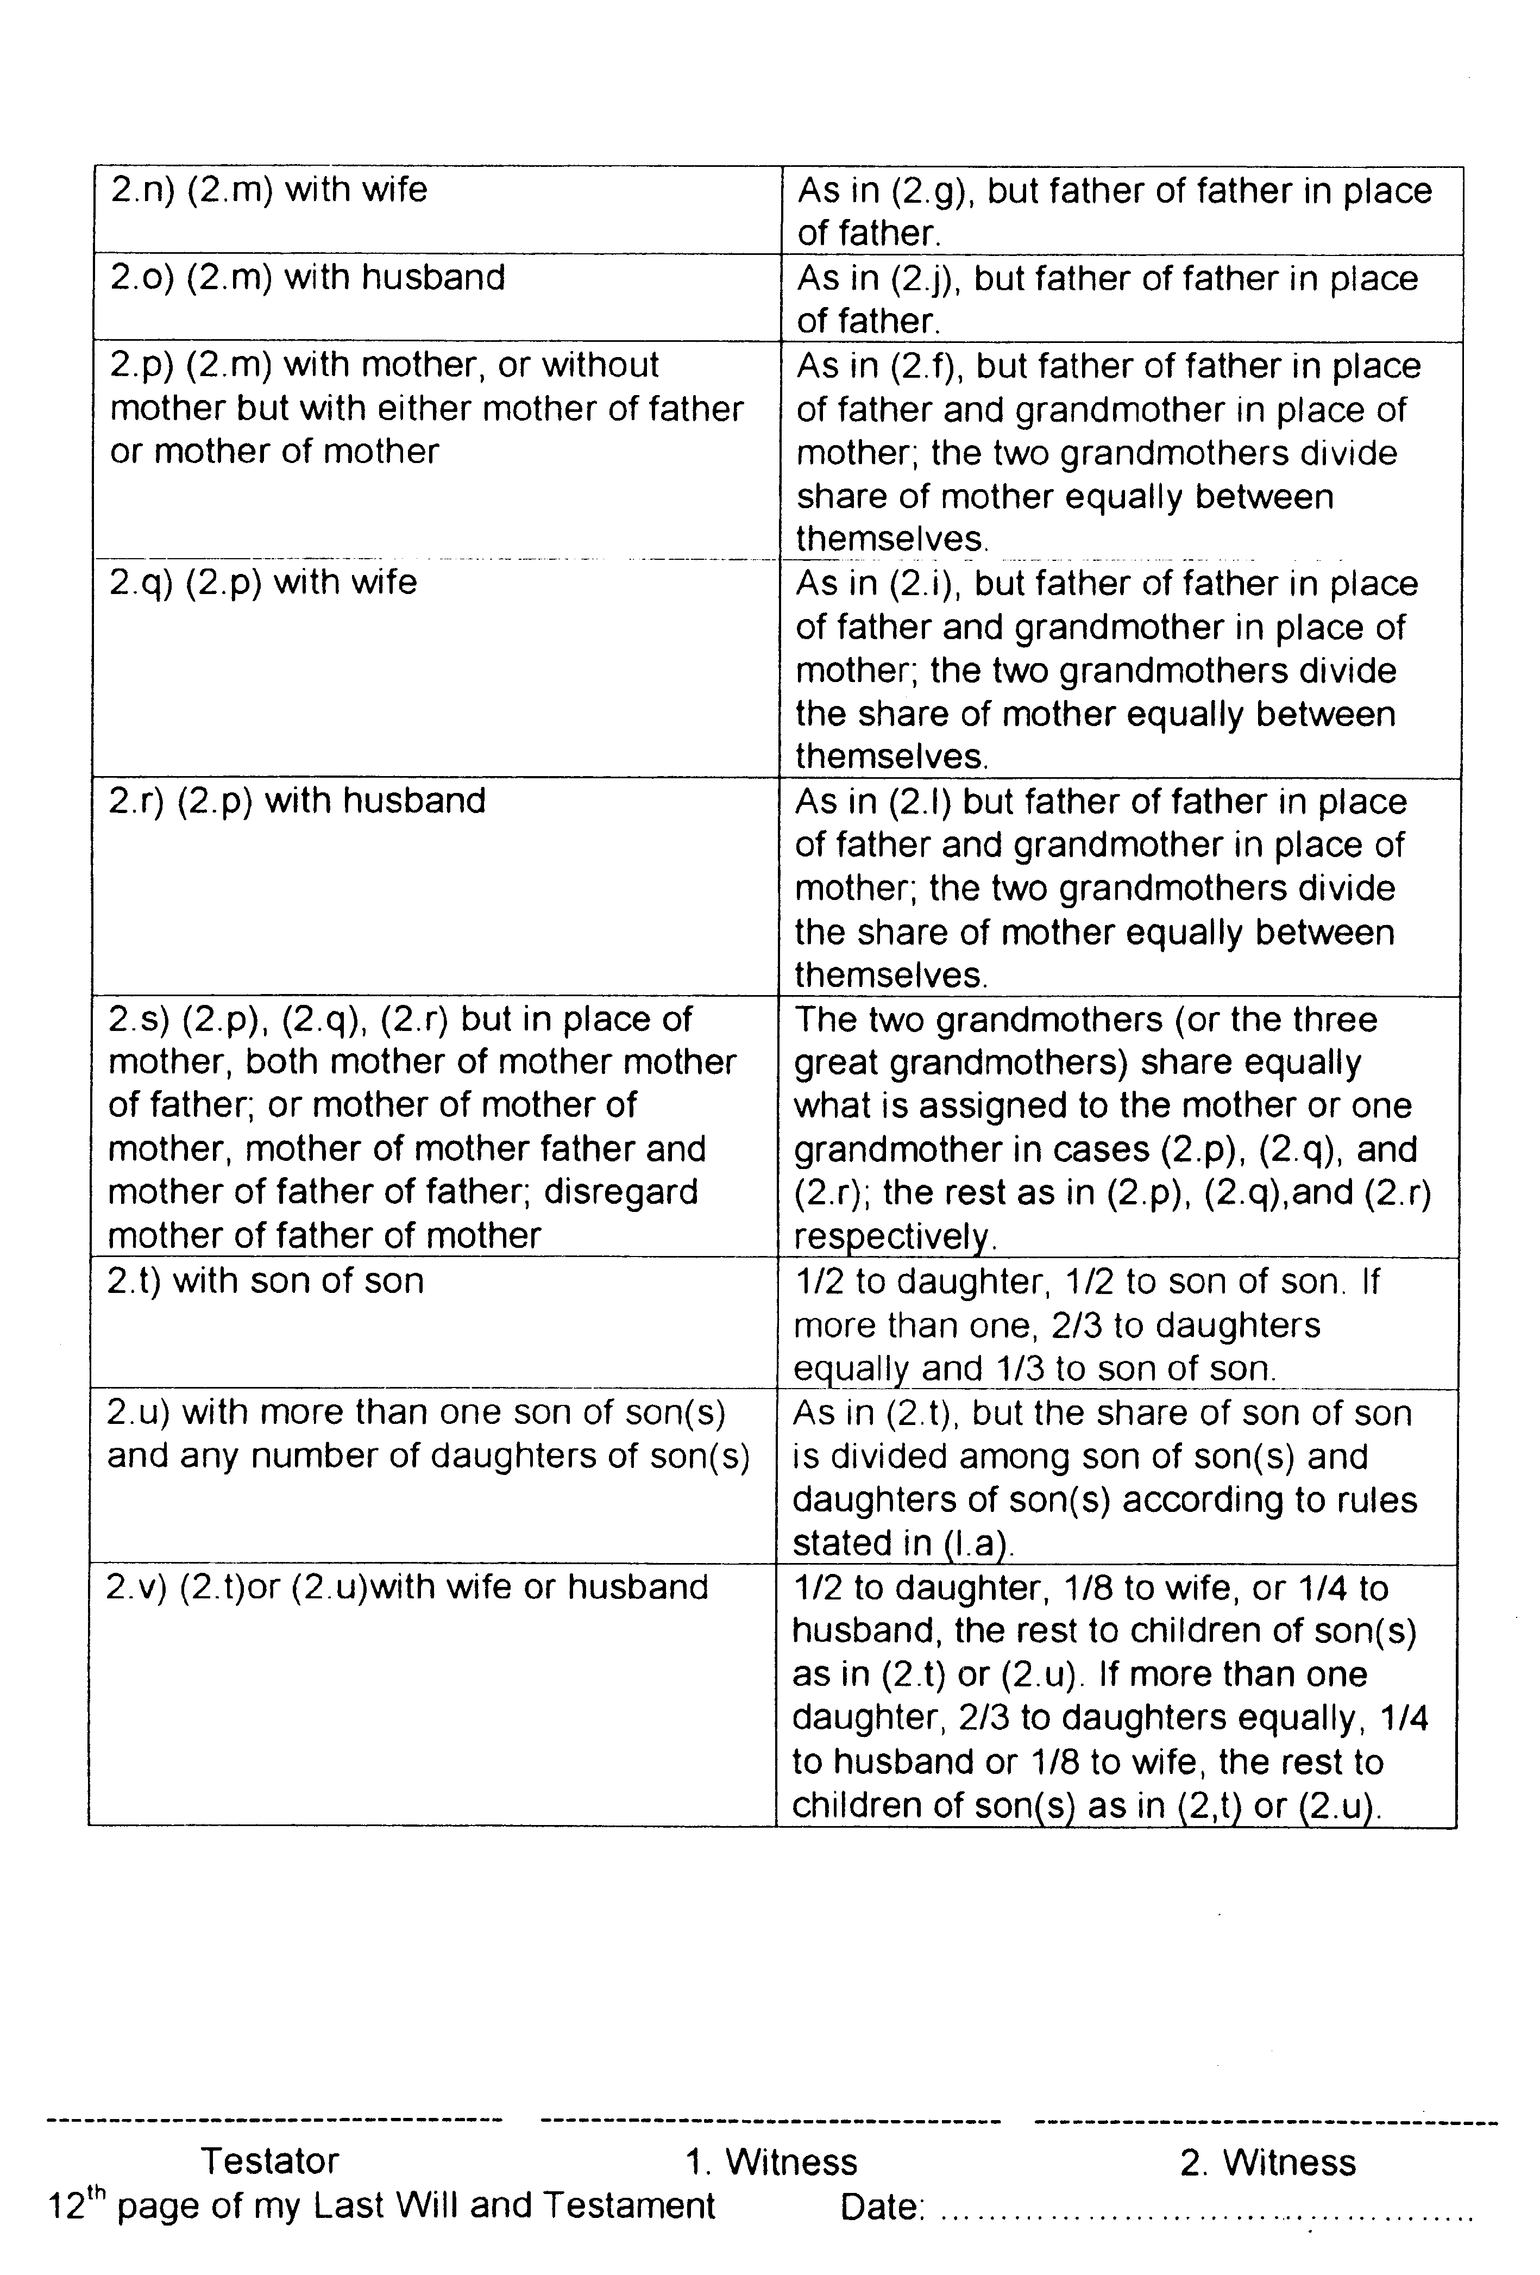
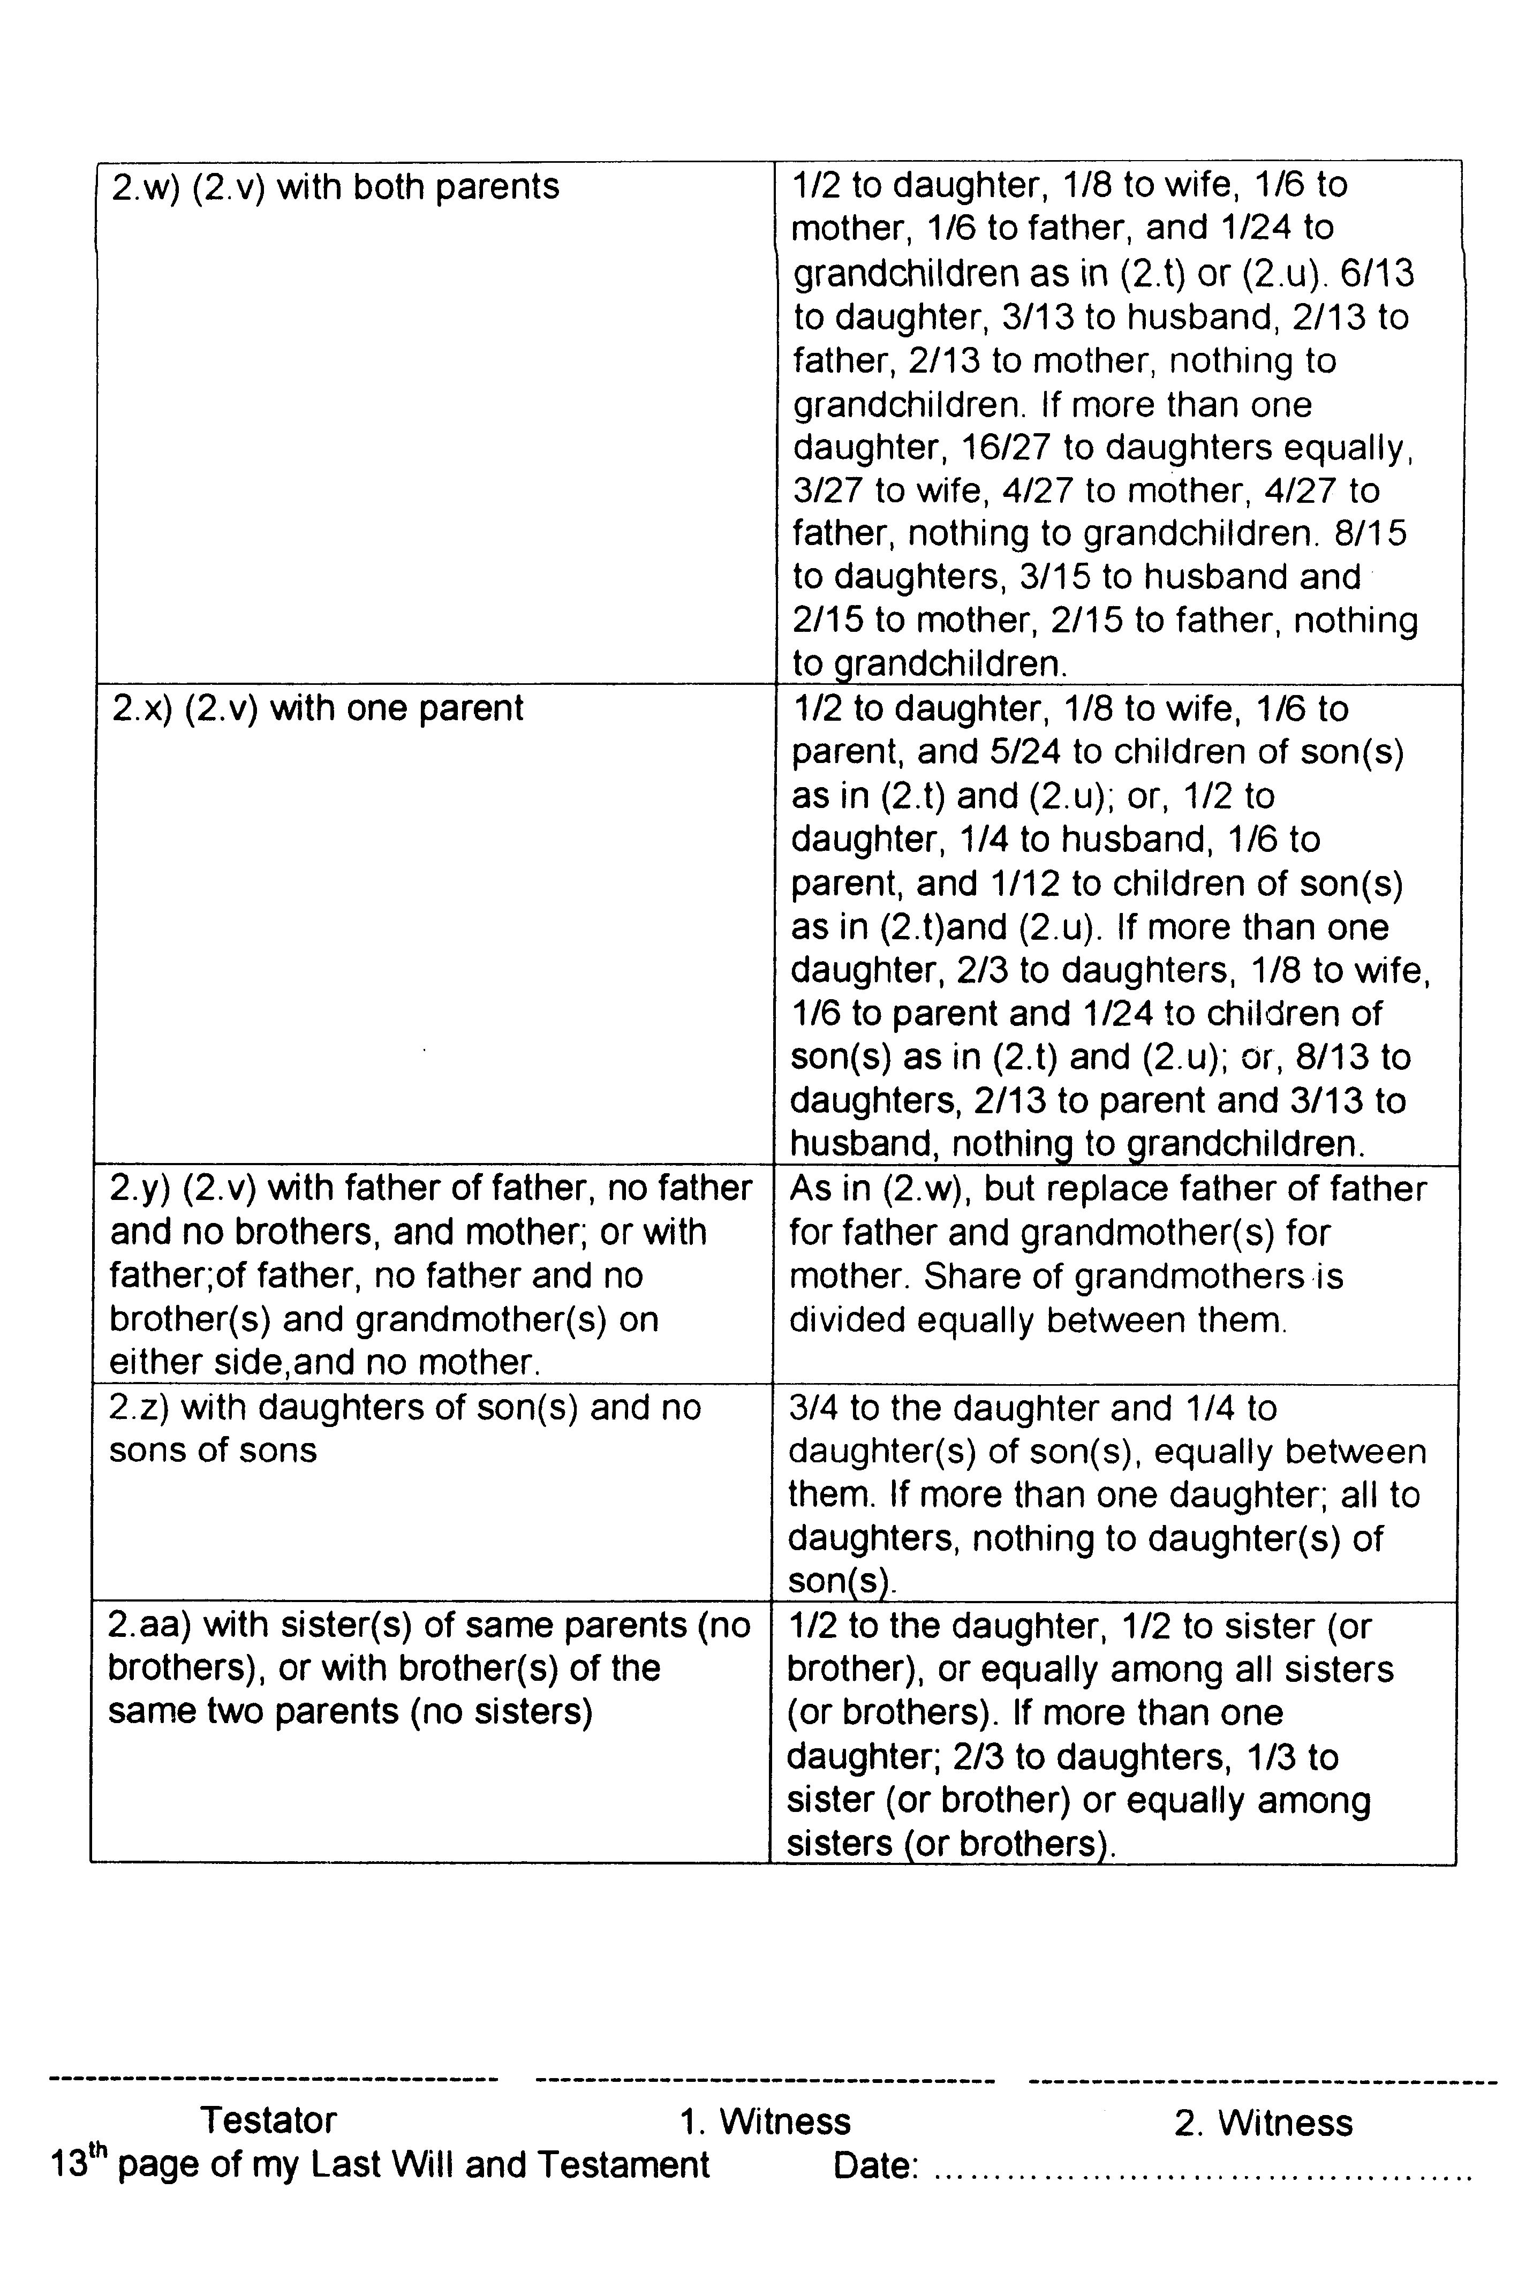
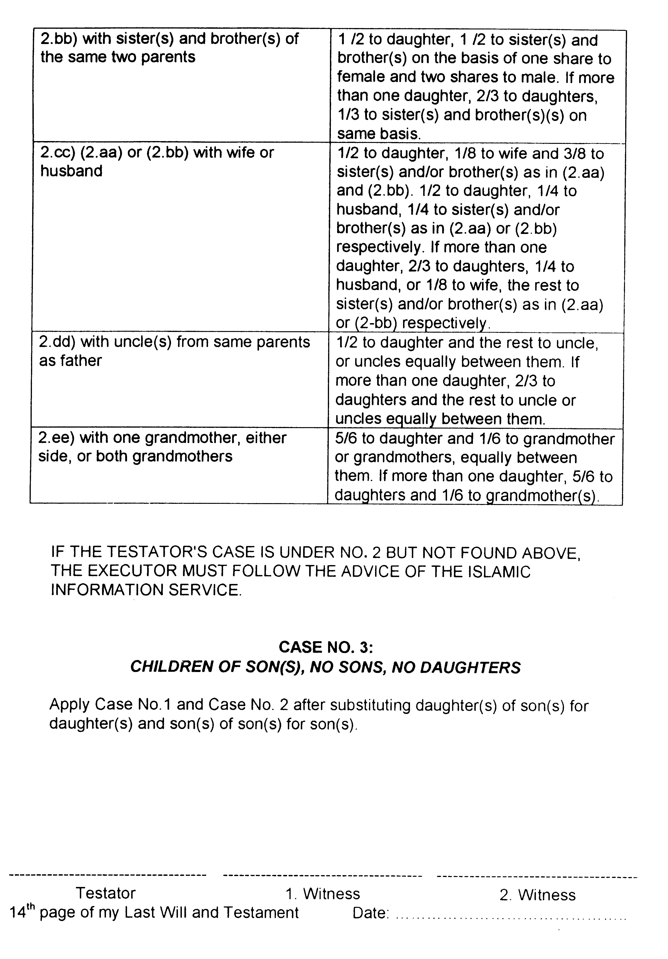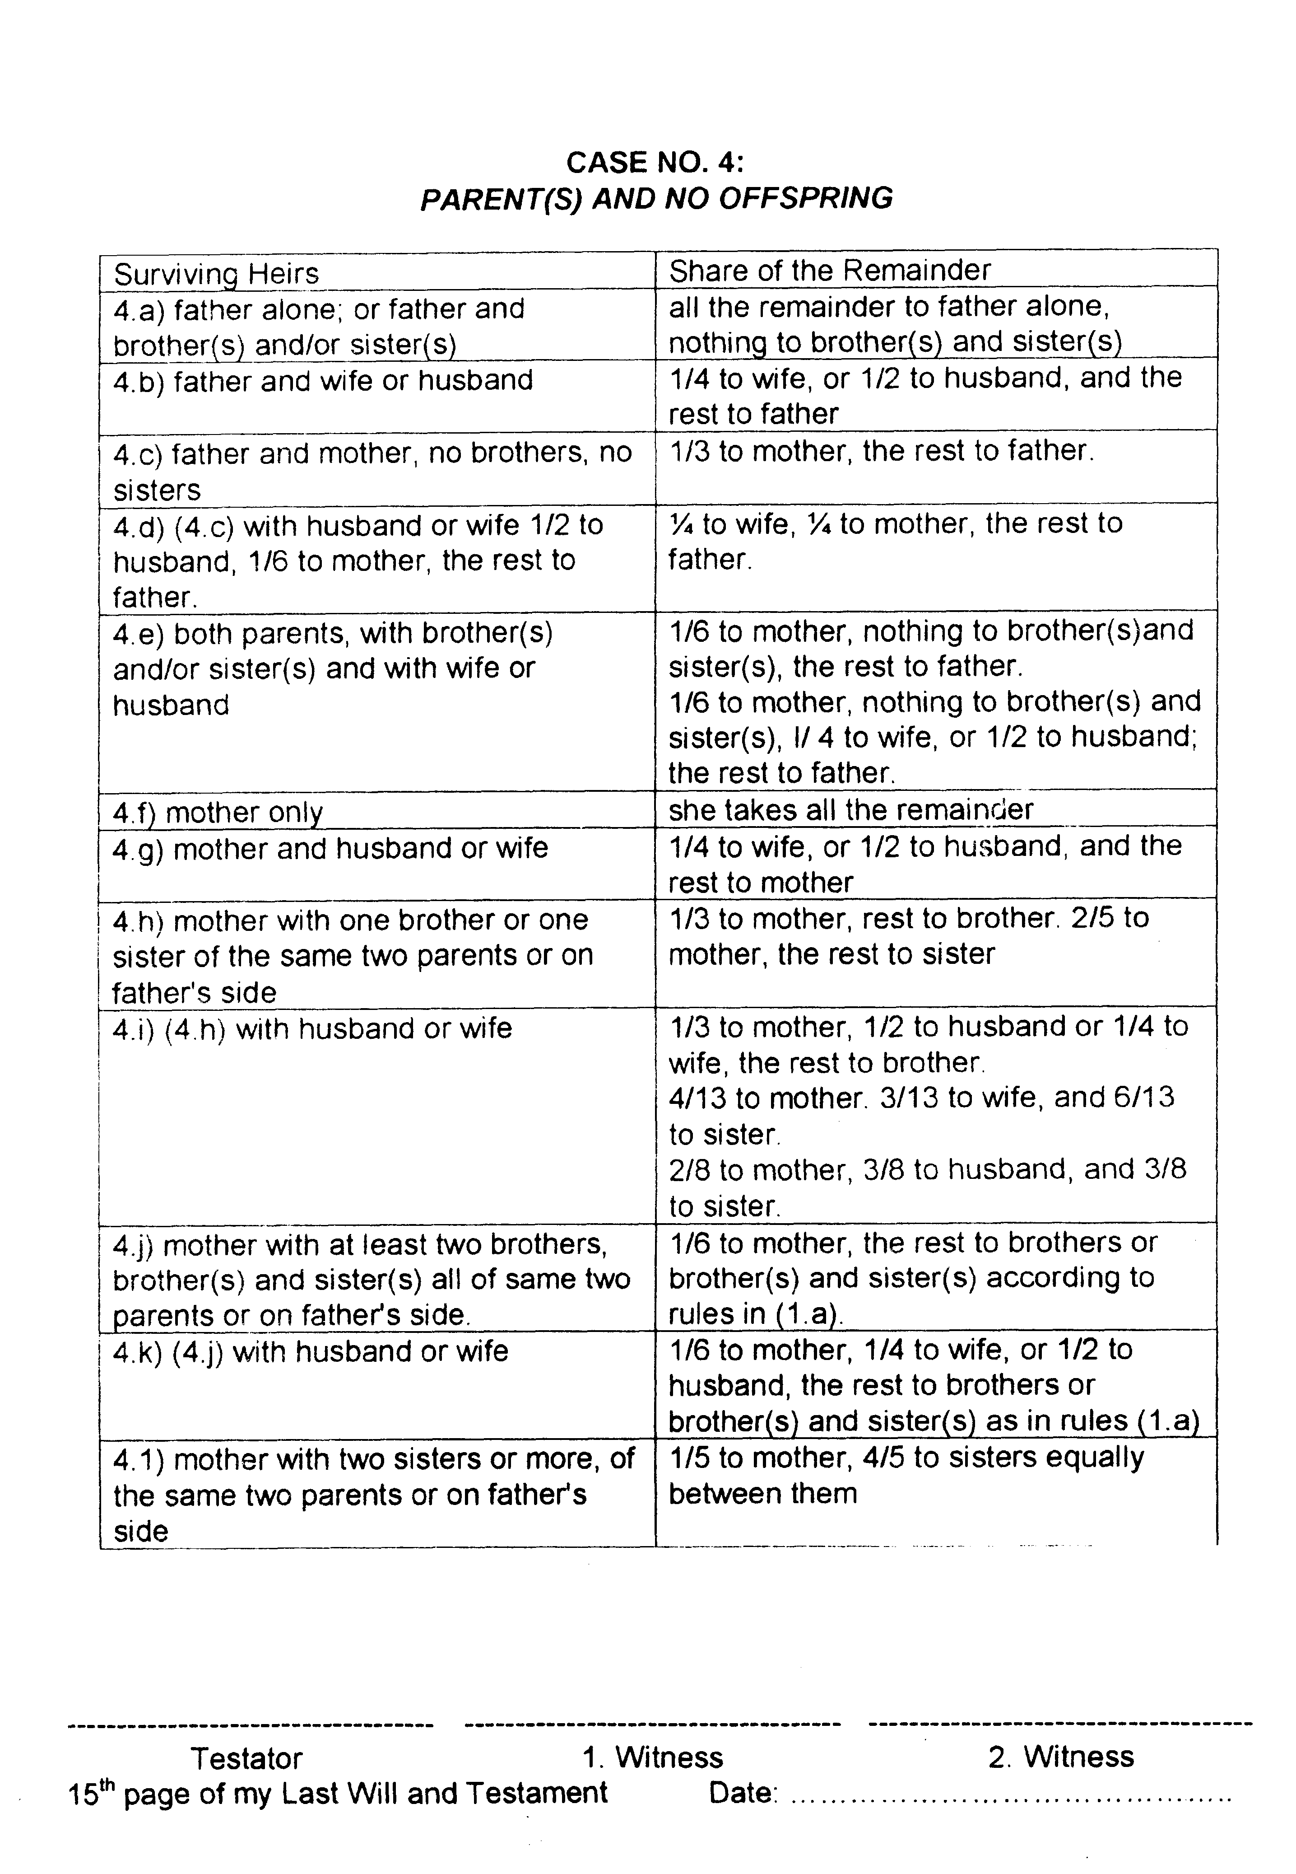
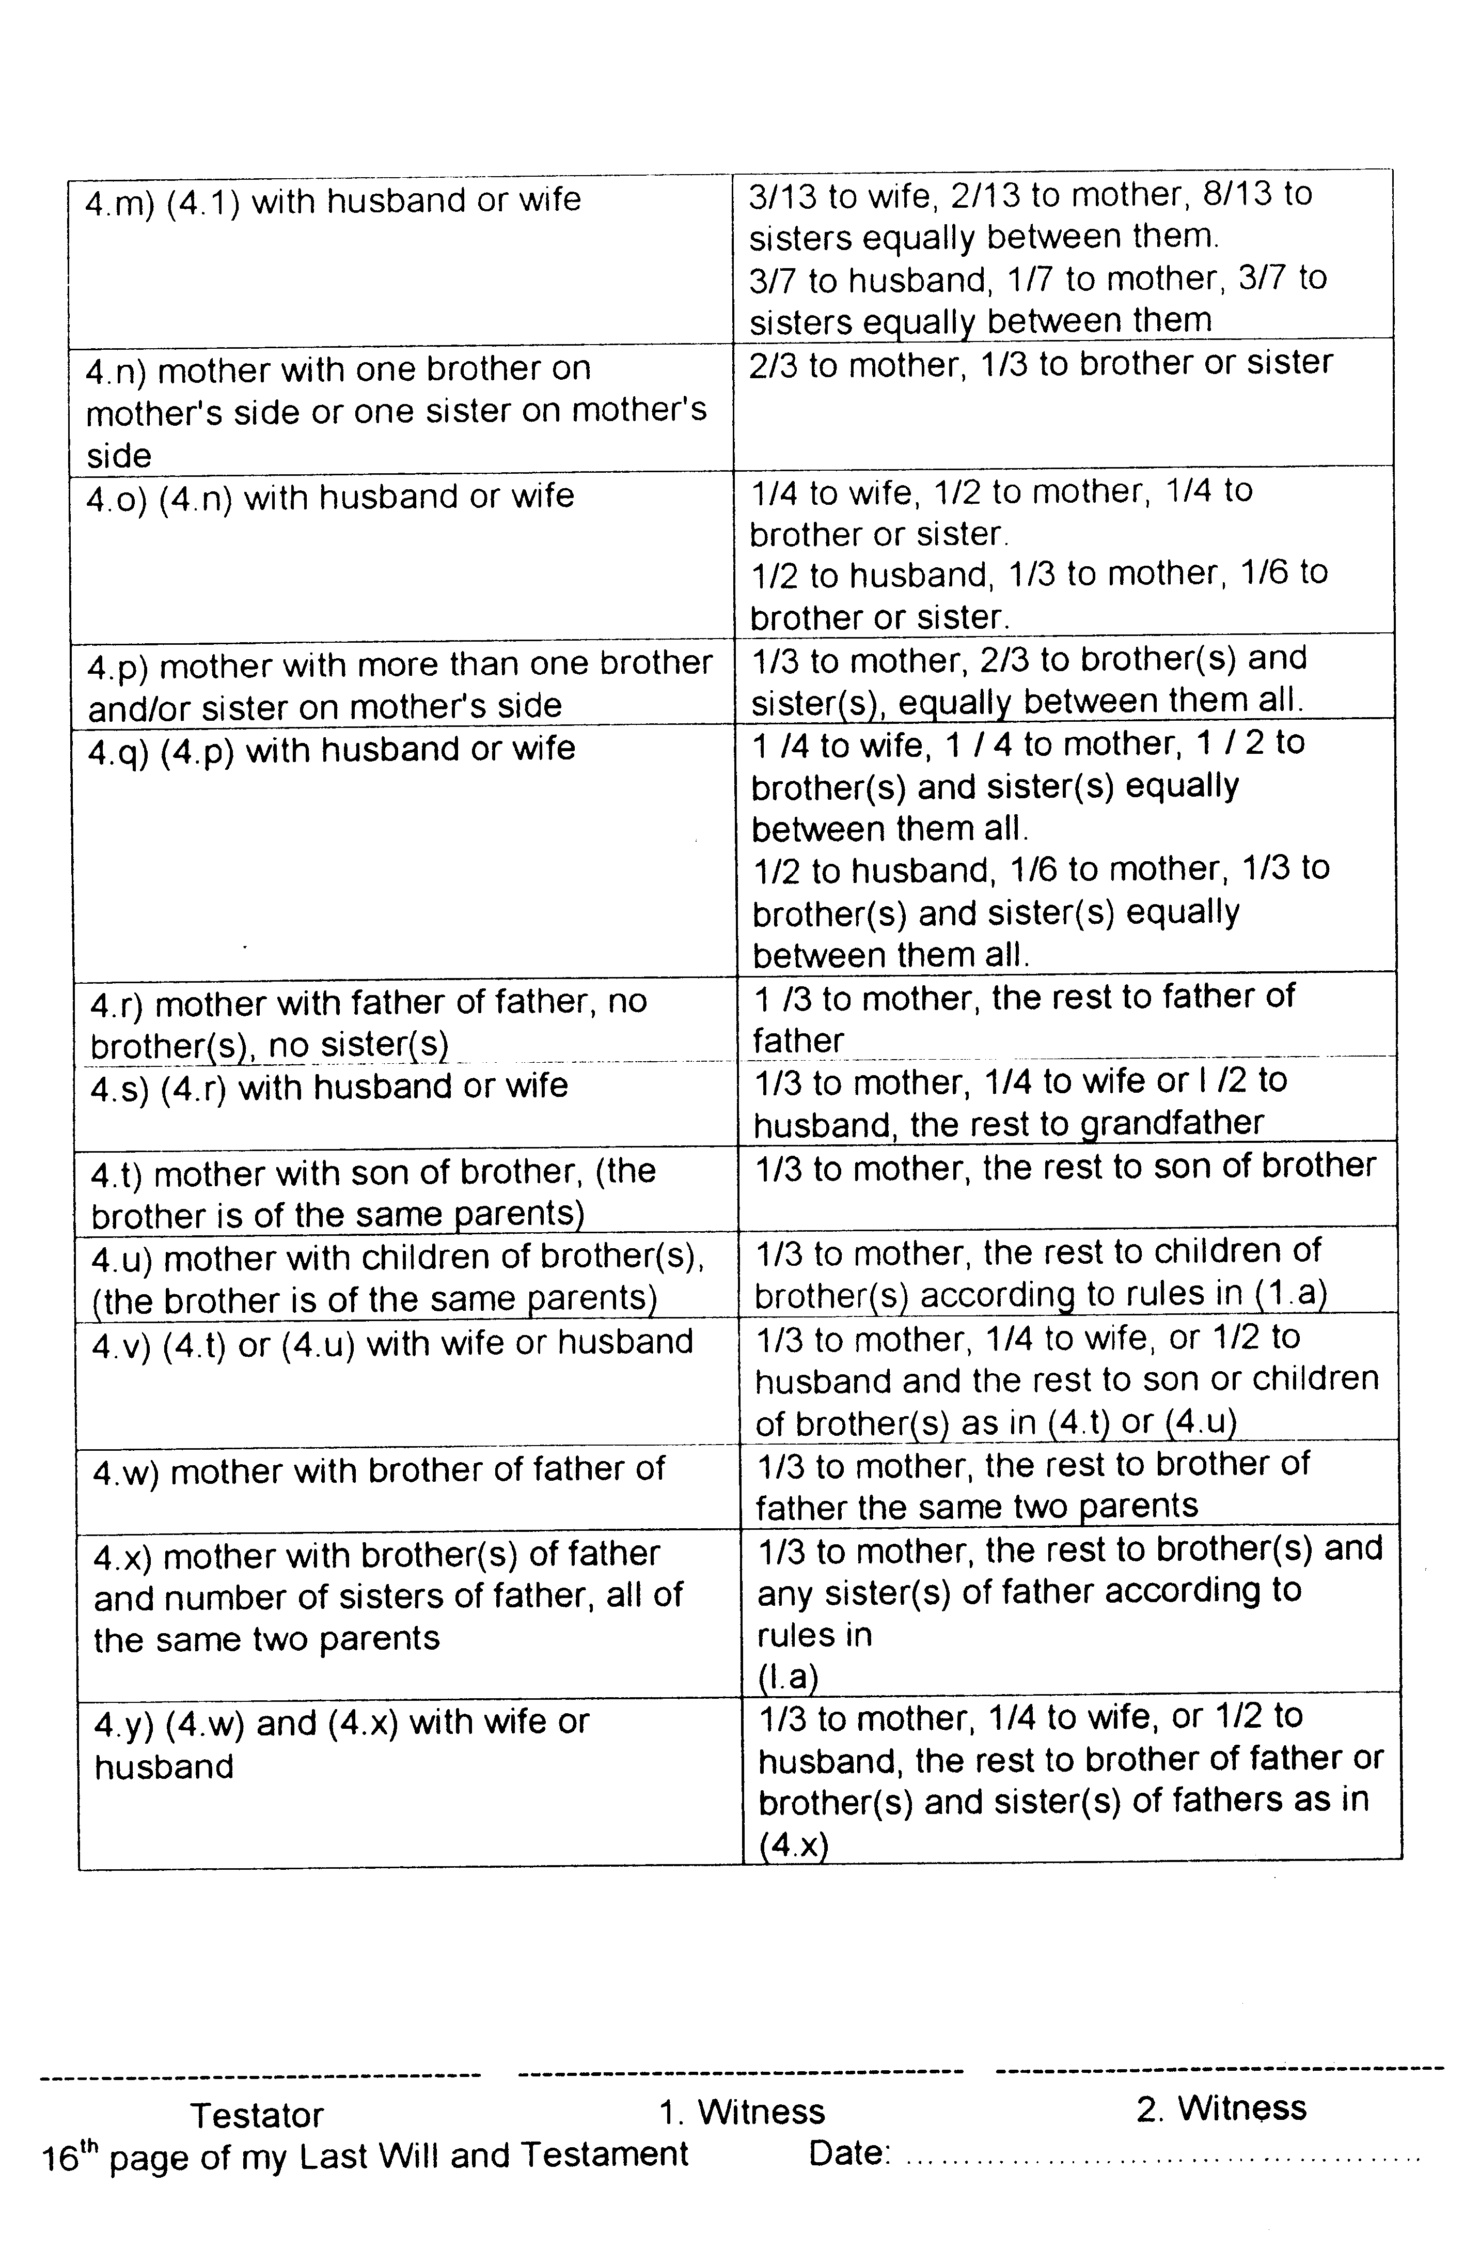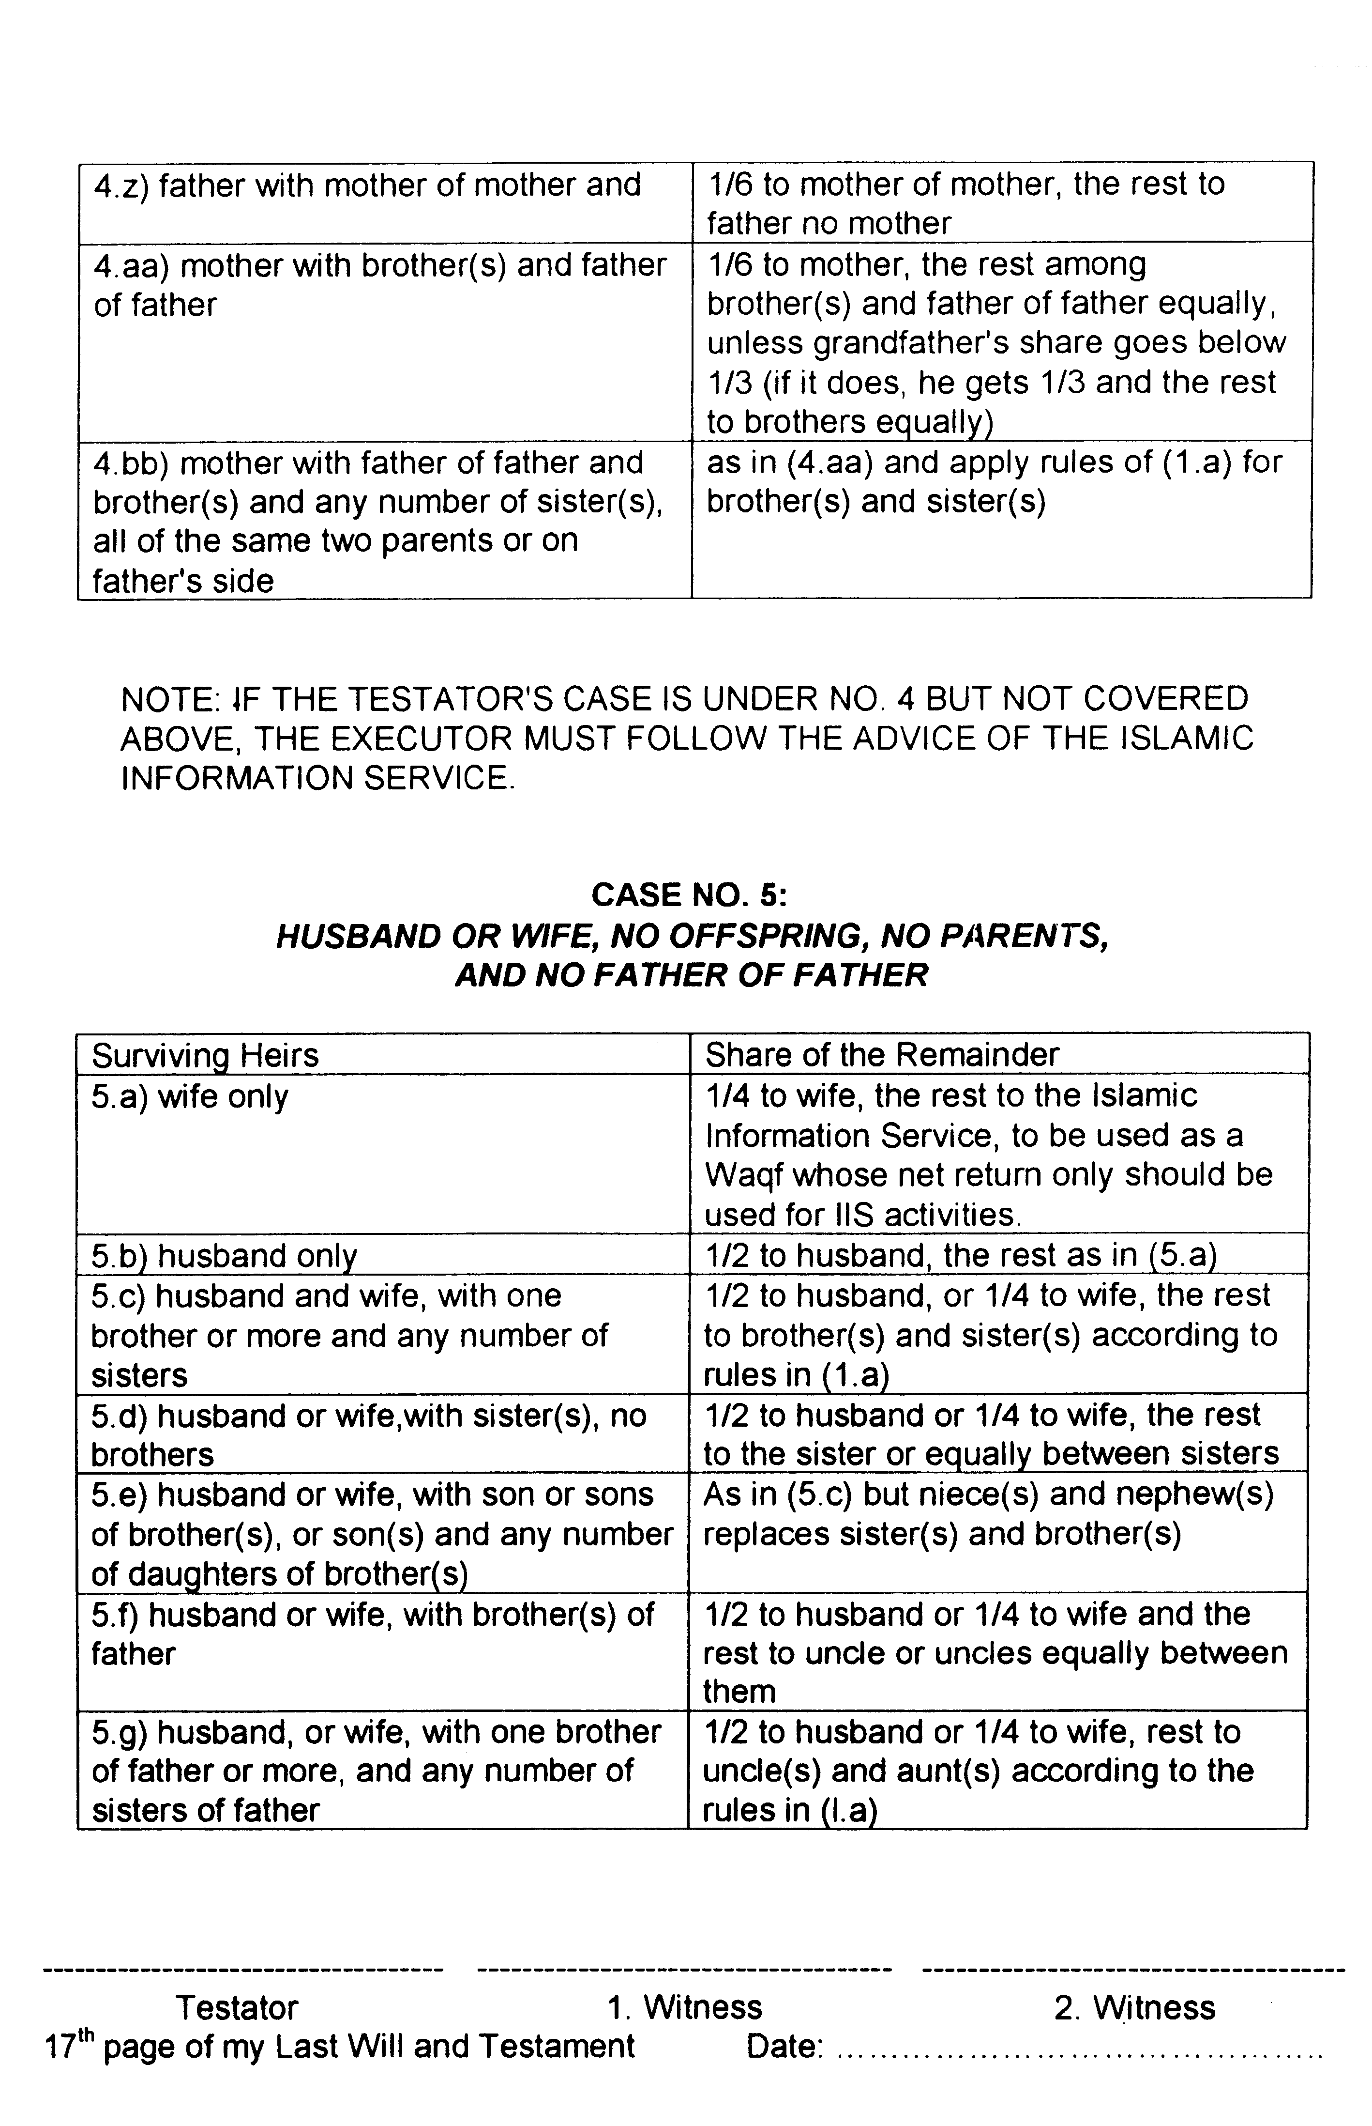
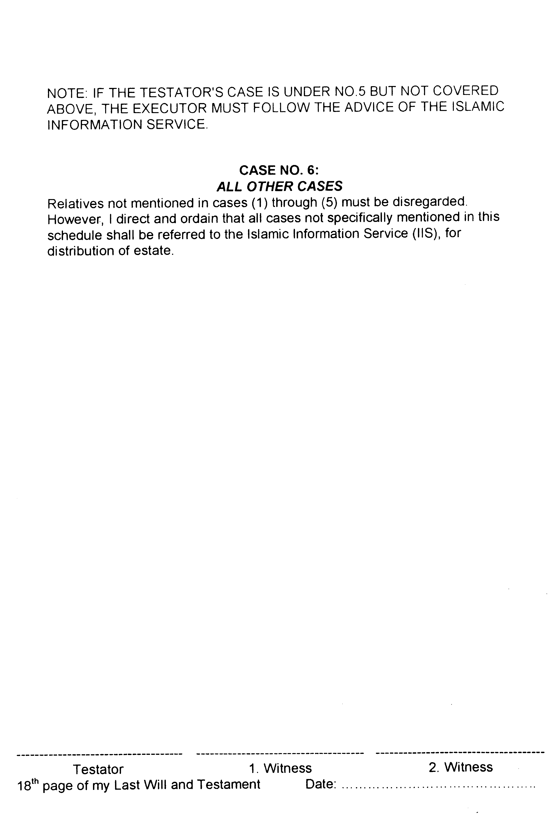
Article VI - Executor & Guardian
a. Appointment of Executor.

I hereby nominate and appoint ………………………………..…………………………………
of the address of ………………………………………...…………………………………………
City of ………………………………………………………………………………………………..
to be the executor of this, my Last Will and Testament.

In the event that he shall be unwilling or unable to act as my executor, I nominate
and appoint ……………………………………………..….……………………………………….
of the address of.……………………………………………..…………………………………….
City of ……………………………………………………..…..…………………………………….
to be the executor of my Will.
I give my executor herein named, power to settle any claim for or against my estate and to sell property, real, personal or mixed, without court order and without bond. However, after my death he must obtain permission from the Supreme Court to do as the Will instructs.
b. Appointment of Guardian
I hereby nominate and appoint …………………………………….…………………………….
of the address of ……………………………………………..…………………………………….
City of ……………………………………………………..…..…………………………………….

to be the guardian of my minor children and their estates after my death assuming that he is a person of integrity. The guardianship is to end when they reach maturity. In the event that ……………………………….. be unwilling or unable to act as guardian, I nominate and appoint ………………………….……………………………………….…………………….
of the address o .……………………………………………..…………………………………….
City of ……………………………………………………..…..…………………………………….
to be the guardian.
Testator………………….. 1. Witness………….…….……… 2. Witness …………….………….
19th page of my Last Will and Testament Date; ……………………….
Article VII - Separability
I direct and ordain that if any part of this Last Will and Testament is determined invalid by a court of competent jurisdiction, the other parts shall remain valid and enforceable.
In witness whereof I have hereunto set my signature …………………………………………….
this ………………………. day of ……………………………. of the year …………………..
………………………………………….. ………………………………………………….
(legal name) (Muslim name)
WE HEREBY CERTIFY that the foregoing instrument was on the date thereof signed, published and declared by the Testator,
as and for his Last Will and Testament, in our presence, who at his request and in his presence, and in the presence of each other, have hereunto subscribed our names as witnesses thereto, believing said Testator at the time of so signing to be found of sound mind and memory.
1. ……………………………………… Name: ……………………………………………
Signature of first witness Address: …………………………………………
…………………………………………………….
…………………………………………………….
Telephone: …………………..…………………
2. ……………………………………… Name: ……………………………………………
Signature of first witness Address: …………………………………………
…………………………………………………….
…………………………………………………….
Telephone: …………………..…………………
From this document ………… copies have been made …………… copy(ies) are with me the Testator, one (1) is with the executor and one (1) is deposited with Islamic Information Service. P. 0. Box 62125, Mt Wellington, Auckland 1130, NZ.
Testator………………….. 1. Witness………….…….……… 2. Witness …………….………….
20th page of my Last Will and Testament Date; ……………………….

